TRAFFIC MANAGEMENT

**Introduction:**

Smart traffic management is a modern approach to managing and optimizing traffic flow in urban areas. It leverages technology, data, and real time information to enhance transportation systems. Key components of smart traffic management include:

**Traffic Monitoring** : Sensors and cameras collect data on traffic conditions, such as vehicle speed, volume, and congestion.

**Data Analytics**: Advanced analytics process the collected data to gain insights into traffic patterns, which can help in making informed decisions.

**Real Time Updates**: Information about traffic conditions is relayed to drivers and traffic management centers in real time, allowing for immediate responses to incidents.

**Traffic Control Systems** : Signals, signs, and adaptive traffic lights can be adjusted dynamically based on real time traffic data to optimize traffic flow.

**Public Transportation Integration**: Smart traffic management often integrates with public transportation systems, providing real time information on bus and train schedules and routes.

**Predictive Modeling**: Machine learning and predictive algorithms can anticipate traffic bottlenecks and suggest optimal routes or timing for commuters.

**Communication Infrastructure**: High speed communication networks enable the seamless exchange of data between vehicles, infrastructure, and control centers.

**Environmental Considerations**: Smart traffic management can help reduce emissions and improve air quality by minimizing traffic congestion.

**Safety Improvements**: By reducing congestion and improving traffic flow, smart traffic management can enhance road safety.

**Smart City Integration**: It's a component of broader smart city initiatives, where data from various sources is used to improve urban living.

**Description:**

Overall, smart traffic management aims to alleviate congestion, reduce commute times, lower environmental impact, and enhance the overall quality of life in cities. It's a crucial aspect of urban planning in the 21st century.

Smart traffic management refers to the use of advanced technology and data driven strategies to efficiently control and optimize traffic flow in urban areas. Here's a more detailed description of its key components and benefits:

**1.Data Collection and Sensors**: Smart traffic management relies on various sensors and data collection devices, such as traffic cameras, in road sensors, and GPS systems, to monitor real time traffic conditions. These devices collect data on vehicle speed, volume, and congestion.

**2.Data Analysis**: The collected data is processed and analyzed using advanced software and algorithms. This analysis helps traffic management centers understand traffic patterns, identify congestion hotspots, and predict potential issues.

**3.Real Time Updates**: Information about current traffic conditions and incidents is disseminated in real time to drivers through mobile apps, electronic signs, and GPS navigation systems. This enables drivers to make informed decisions about their routes.

**4.Adaptive Traffic Control**: Traffic lights and signals can be dynamically adjusted based on real time traffic data. Adaptive traffic control systems prioritize the smooth flow of traffic, reducing wait times and congestion.

**5.Public Transportation Integration**: Smart traffic management often integrates with public transportation systems. It provides real time information on bus and train schedules, as well as route optimization, to encourage the use of public transit.

**6.Predictive Modeling**: Advanced algorithms can forecast traffic conditions and incidents, allowing for proactive traffic management strategies. This includes rerouting traffic, adjusting signal timings, and deploying resources to address issues before they escalate.

**7.Communication Infrastructure**: High speed communication networks, including 5G and IoT

(Internet of Things) technologies, facilitate data exchange between vehicles, infrastructure, and traffic management centers.

**8.Environmental Considerations**: Smart traffic management contributes to reducing emissions and improving air quality by minimizing traffic congestion and optimizing traffic flow.

**9.Safety Improvements**: By reducing congestion and improving traffic flow, smart traffic management enhances road safety and reduces the likelihood of accidents.

**10.Smart City Integration**: It's a fundamental component of broader smart city initiatives, where data from various sources is used to enhance urban living, transportation, and sustainability.

**IOT Devices:**

**1.Traffic Cameras**: IoT enabled cameras capture real time images and video of traffic conditions, helping monitor and analyze traffic patterns.

**2.Traffic Sensors**: In road or roadside sensors detect the presence and speed of vehicles, providing data for traffic management and analytics.

**3.Variable Message Signs (VMS**): Digital signs with IoT connectivity display real time information to drivers, such as traffic conditions, road closures, and alternate routes.

**4.Roadside Beacons**: These IoT devices provide data on traffic conditions and help coordinate traffic signals and congestion management.

**5.GPS and Navigation Systems**: IoT enabled GPS devices and navigation apps provide real time traffic data and suggest alternate routes to drivers.

**6.Smart Traffic Lights**: Adaptive traffic lights use IoT technology to adjust signal timings based on traffic flow, reducing congestion and optimizing traffic.

**7.Electronic Toll Collection Systems**: IoT enabled toll booths and transponders facilitate automatic toll collection and traffic management.

**8.Public Transportation Systems**: Buses and trains equipped with IoT devices transmit real time location and schedule information, helping commuters plan their journeys.

**9.Weather Sensors**: IoT connected weather stations provide data on current weather conditions, which can influence traffic management decisions.

**10.Parking Sensor:** IoT sensors in parking lots and on streets provide real time information on available parking spaces, reducing traffic caused by drivers searching for parking.

**11.Mobile Apps**: Smartphone apps with IoT connectivity offer real time traffic updates, route planning, and incident reporting for drivers.

**12.Vehicle to Infrastructure (V2I) Communication:** IoT enabled vehicles can communicate with infrastructure (e.g., traffic lights) to optimize traffic flow and enhance safety.

**13.Traffic Management Software**: IoT based traffic management software collects, analyzes, and visualizes data from various IoT devices to make informed decisions and optimize traffic flow.

**14.Smart Street Lighting:** Streetlights with IoT connectivity can adjust lighting levels based on traffic and pedestrian activity, saving energy and improving safety.

**15.Environmental Sensors**: IoT devices measuring air quality and emissions help monitor environmental impact and make adjustments to traffic flow to reduce pollution.

**Device Setup:**

These IoT devices work together to create a networked system that collects and shares data, enabling real time traffic monitoring, adaptive control, and efficient management of urban traffic.

Setting up IoT devices for smart traffic management involves a detailed process. Here's a step by step guide to set up IoT devices for this purpose:

**1.Needs Assessment:**

Identify the specific traffic management needs in your area, including congested intersections, accident prone zones, or areas with environmental concerns.

**2.Device Selection:**

Choose the appropriate IoT devices based on your needs. Common devices include traffic cameras, sensors, variable message signs, and smart traffic lights.

**3. Infrastructure Preparation:**

Ensure that the installation sites have necessary infrastructure in place, such as power sources and network connectivity.

**4.Installation Planning**:

Plan the physical installation of devices, considering factors like visibility, coverage, and protection from environmental elements.

**5.Power Supply**:

Ensure reliable power sources for IoT devices. This may involve electrical outlets, solar panels, or batteries, depending on the device.

**6.Network Connectivity**:

Establish a robust and secure network connection for each IoT device. This could be wired or wireless, depending on device capabilities.

**7.Device Configuration**:

Configure each IoT device according to its specifications, including data collection parameters, transmission intervals, and communication protocols.

**8.Data Integration**:

Set up a central data management system, such as a cloud based platform or local servers, for storing and analyzing the data collected.

**9.Real Time Data Handling**:

Implement software and systems for real time data processing, analysis, and visualization. Use traffic management software and dashboards for this purpose.

**10.Communication Protocols**:

Ensure that all IoT devices and data management systems use compatible communication protocols for data exchange.

**11.Testing and Calibration:**

Conduct thorough testing and calibration of each IoT device to verify accurate data collection and transmission.

**12.Security Measures**:

Implement robust security measures to protect IoT devices and data from cybersecurity threats and unauthorized access.

**13.Remote Monitoring and Control**:

Enable remote monitoring and control capabilities to manage and adjust IoT devices as needed.

**14.Scalability and Upgradability**:

Consider future scalability and upgradability of the system to accommodate changing traffic patterns and emerging technologies.

**15.Training and Education**:

Train staff and stakeholders on how to operate and maintain the smart traffic management system effectively.

**16.Data Utilization:**

Develop strategies for utilizing the data collected by IoT devices to optimize traffic flow, reduce congestion, and enhance safety.

**17.Regular Maintenanc**:

Establish a maintenance schedule to ensure the continued functionality of IoT devices and perform necessary repairs or updates.

**18.Monitoring and Optimization:**

Continuously monitor the performance of the IoT devices and make adjustments as needed to improve traffic management.

The setup of IoT devices for smart traffic management is a comprehensive process that requires careful planning, effective installation, and ongoing management to ensure the system operates efficiently and contributes to the goals of optimizing traffic flow and improving urban mobility.

**Platform Development:**

**Define Objectives and Requirements**:

Clearly outline the objectives of your smart traffic management platform, such as reducing congestion, improving safety, and optimizing traffic flow. Identify specific requirements and performance metrics.

**Select IoT Devices**:

Choose appropriate IoT devices, including traffic cameras, sensors, smart traffic lights, variable message signs, and other relevant equipment, based on your objectives.

**Data Collection and Integration** :

Develop the infrastructure and data collection mechanisms to gather real time traffic data from IoT devices. Ensure the compatibility of different data sources.

**Data Processing and Analysis**:

Build data processing algorithms and analytical tools to interpret the collected data. This includes traffic pattern analysis, incident detection, and predictive modeling.

* **Real-time traffic data**

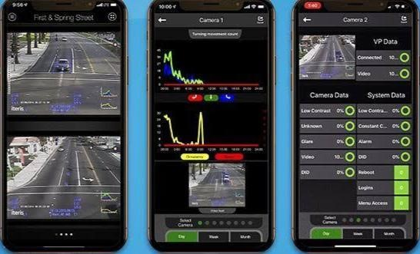

* **Parking availablity**

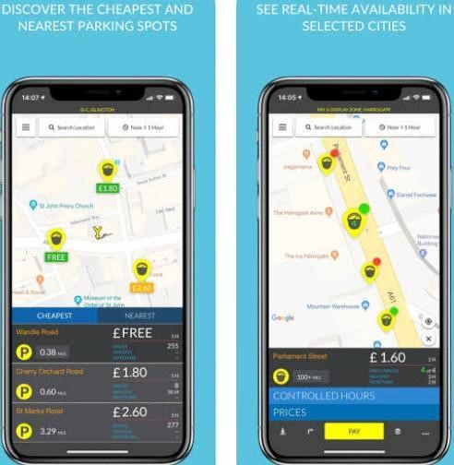

* **Public transportation information**

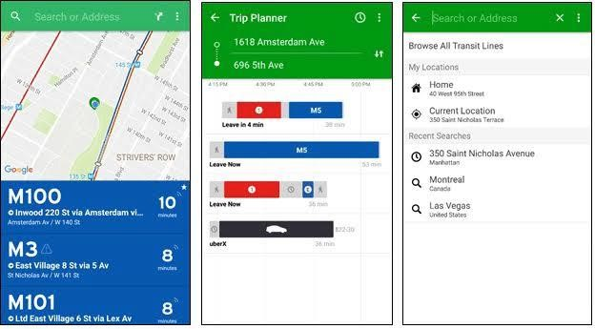

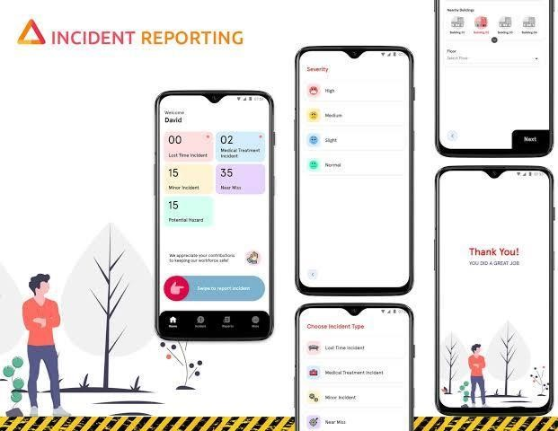

**Real Time Monitoring and Control:**

Implement a system for real time monitoring of traffic conditions. Develop control mechanisms for adaptive traffic lights and variable message signs.

**Communication Infrastructure**:

Set up a reliable and secure communication network to connect IoT devices, data processing centers, and control systems. Consider both wired and wireless solutions.

**Cloud Based Data Storage**:

Use cloud based storage solutions to store and manage the vast amount of traffic data efficiently. Ensure data security and backup procedures.

**User Interface and Dashboards:**

Create user friendly dashboards and interfaces for traffic management personnel, allowing them to visualize real time traffic data and make informed decisions.

**Security and Privacy**:

Implement strong cybersecurity measures to protect the platform from cyber threats. Ensure data privacy and compliance with relevant regulations.

**Scalability and Redundancy**:

Design the platform to be scalable, allowing for the addition of more IoT devices and data sources as needed. Implement redundancy for critical components to ensure system reliability.

**Integration with Public Transit** :

Integrate public transportation data, including bus and train schedules, to provide commuters with real time information and route optimization.

**Environmental Consideration :**

Implement tools for monitoring air quality and environmental impact, and integrate these data into the platform to support sustainability efforts.

**Traffic Prediction and Incident Management**:

Develop predictive modeling and incident management systems to anticipate traffic issues and respond effectively to accidents or congestion.

**Data Visualization and Reporting**:

Create tools for data visualization and reporting to share insights with stakeholders, local authorities, and the public.

**Testing and Quality Assurance**:

Thoroughly test the platform to ensure its reliability, accuracy, and performance under various conditions.

**Training and Education**:

Provide training for traffic management personnel and stakeholders on how to use the platform effectively.

**Maintenance and Updates**:

Establish a maintenance plan to ensure the continuous operation of the platform and schedule regular updates to keep it current with technological advancements.

**User Feedback and Improvement**:

Collect user feedback to identify areas for improvement and further develop the platform's capabilities.

**Code Implementation:**

import RPi.GPIO as GPIO import cv2

# GPIO setup for traffic light sensors

RED_LIGHT_PIN = 17

GREEN_LIGHT_PIN = 18

LOOP_SENSOR_PIN = 27

GPIO.setmode(GPIO.BCM)

GPIO.setup(RED_LIGHT_PIN, GPIO.IN)

GPIO.setup(GREEN_LIGHT_PIN, GPIO.IN)

GPIO.setup(LOOP_SENSOR_PIN, GPIO.IN)

# Camera setup cap = cv2.VideoCapture(0) # Camera index, adjust as needed

while True:

# Read sensor states red_light_active = GPIO.input(RED_LIGHT_PIN) green_light_active = GPIO.input(GREEN_LIGHT_PIN) vehicle_detected = GPIO.input(LOOP_SENSOR_PIN)

# Capture a frame from the camera ret, frame = cap.read() if not ret:

break

# Process the frame for object detection or tracking

# Implement computer vision algorithms

# Your traffic management logic here: if red_light_active: # Handle red light scenario

pass

elifgreen_light_active: # Handle green light scenario

pass

if vehicle_detected:

# Vehicle presence detected by loop detector

pass

# Display the processed frame cv2.imshow('Traffic Camera', frame)

if cv2.waitKey(1) & 0xFF == 27: # Press 'Esc' key to exit break

cap.release() cv2.destroyAllWindows()

**DIAGRAM:**

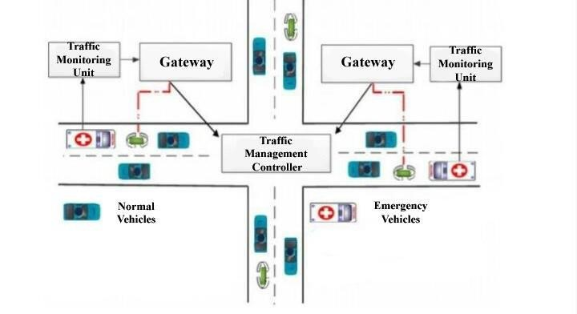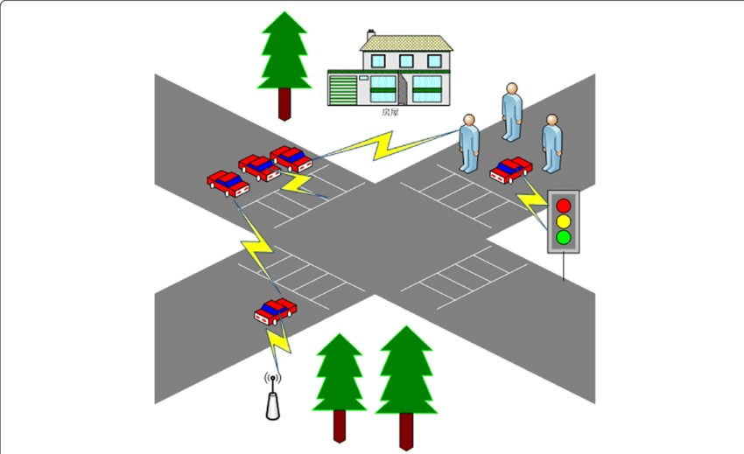

**SCHEMATIC DIAGRAM:**

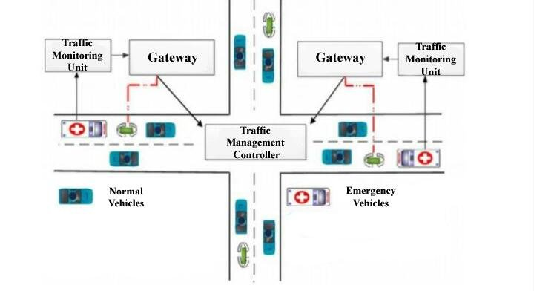**SCREENSHOT:** 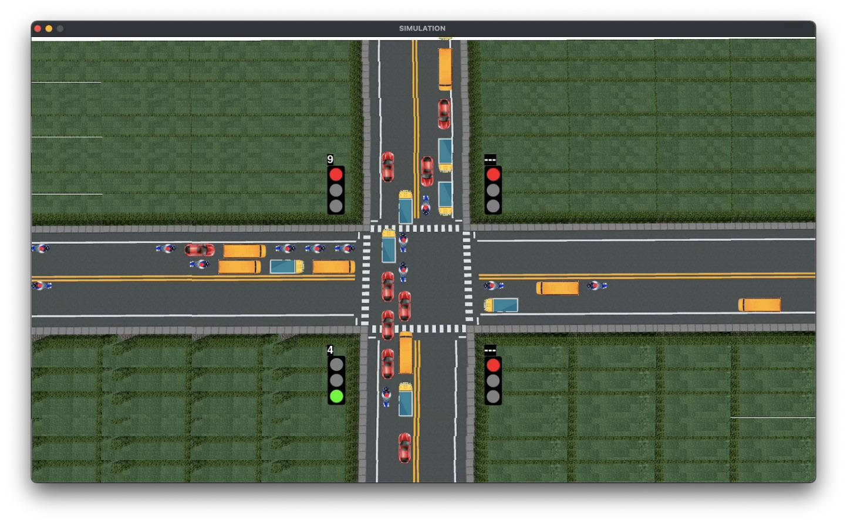

**DATA SHARING:**

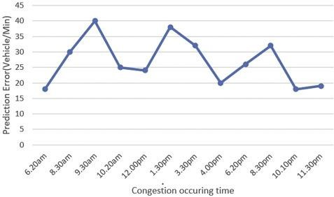

**CIRCUIT DIAGRAM:**

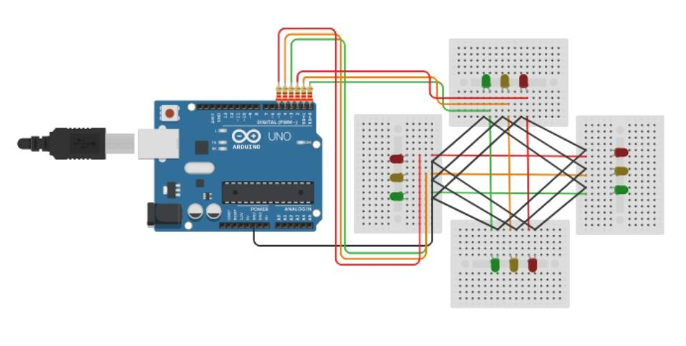

**Project In Detail:**

**Project Overview:**

The Smart Traffic Management System is designed to enhance the efficiency, safety, and sustainability of urban transportation by leveraging cutting edge technologies such as IoT, AI, and data analytics. This system aims to reduce traffic congestion, minimize accidents, and improve the overall quality of life for residents.

**Project Components**:

**1.Traffic Surveillance**:

Install a network of CCTV cameras and sensors at key traffic points.

Use computer vision to monitor traffic conditions, detect congestion, and capture real time data.

**2.Data Collection and Analysis**:

Gather data on vehicle counts, speeds, and congestion levels.

Utilize machine learning algorithms to analyze data patterns.

Identify traffic hotspots and congestion prone areas.

**3.Traffic Light Optimization**:

Implement adaptive traffic signal control systems that adjust signal timing based on real time traffic data.

Prioritize emergency vehicles and public transportation.

**4.Dynamic Signage:**

Deploy electronic message boards to provide real time traffic updates and alternative route suggestions to drivers.

**5.Public Transportation Integration**:

Integrate buses and trams into the system to enhance their efficiency.

Offer real time transit information to passengers.

**6.Mobile Apps and Web Platforms**:

Develop mobile apps and websites to provide drivers and commuters with traffic information and route suggestions.

Enable users to report accidents, road hazards, and other incidents.

**7.Traffic Prediction:**

Use historical data and machine learning to predict traffic conditions during peak hours or special events.

Provide predictive alerts to drivers.

**8.Emergency Response**:

Integrate the system with emergency services for faster response to accidents and incidents.

Automatically clear traffic lanes for emergency vehicles.

**9.Environmental Impact**:

Monitor air quality and emissions.

Implement eco friendly traffic management strategies to reduce pollution.

**10.Feedback Mechanism**:

Encourage public feedback and suggestions through the app or website.

Continuously improve the system based on user input.

Benefits of real-time traffic monitoring systems for city planners:

* **Improved traffic flow:** City planners can use real-time traffic data to identify and address congestion hotspots.
* **Reduced emissions:** By improving traffic flow, real-time traffic monitoring systems can help to reduce vehicle emissions.
* **Increased safety:** City planners can use real-time traffic data to identify and address safety hazards.
* **Improved public transportation:** City planners can use real-time traffic data to improve the efficiency and effectiveness of public transportation systems.

*).Overall, real-time traffic monitoring systems can provide a number of benefits for both commuters and city planners. By improving traffic flow, reducing congestion, and increasing safety, these systems can make our cities more livable and sustainable.

*).Here is an example of how a commuter can use a real-time traffic monitoring system to make an optimal route decision:

*).A commuter is planning their trip to work. They check a real-time traffic monitoring app and see that their usual route is heavily congested. The app suggests an alternative route that is less congested. The commuter decides to take the alternative route and saves time on their trip.

**Challenges:**

. Data privacy and security concerns.

. High initial implementation costs.

. Integration with existing infrastructure.

. Public adoption and acceptance.

**Conclusion:**

A Smart Traffic Management System can significantly improve urban transportation by harnessing the power of technology and data analytics. It promises to create safer, more efficient, and environmentally friendly cities, ultimately benefiting both residents and the environment.